the first step is to sense or perceive the world.
the second step is to decide what to do based on that perception.
and the third step is to perform an action to carry out that decision.
radar and lidar see the world in 3D

从真实世界三维坐标到二维图像坐标的变换矩阵，叫做相机矩阵；
失真的类型：
1.radial distortion:真实相机用弯曲镜头来成像，光线在镜头边缘处经常弯曲，称为径向失真；
2.tangential distortion:切向失真，镜头未完全平行于成像面时，使得图像看起来倾斜；

失真系数和矫正：
1.radial distortion系数有三个：k1,k2 and k3. 可以使用矫正公式校正径向扭曲了图像；

Distortion_coefficients = (k1 k2 p1 p2 k3)一般用五个参数可以消除失真；
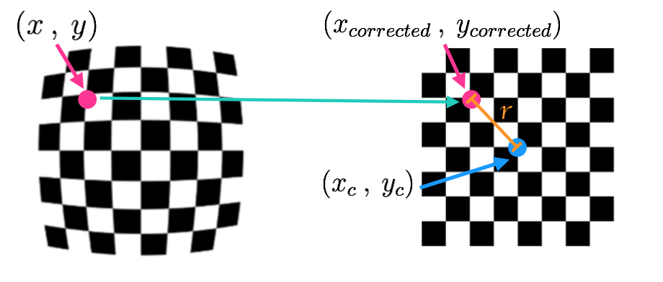
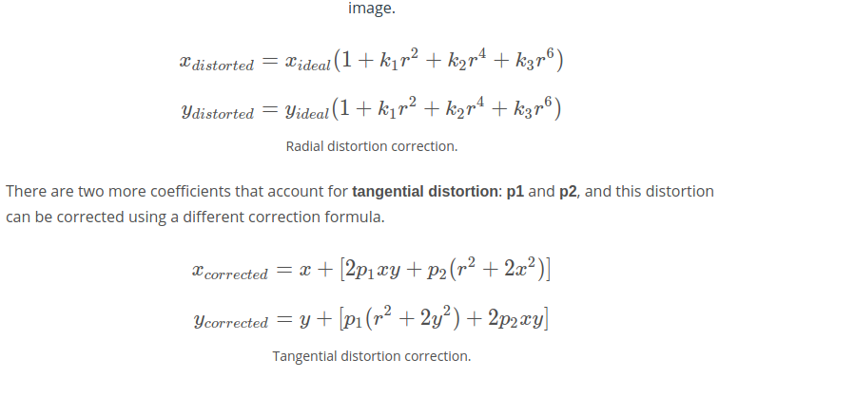
相机标定：
用到的opencv函数
1.gray = cv2.cvtColor(img,cv2.COLOR_BGR2GRAY)
2.Finding chessboard corners (for an 8x6 board):
ret, corners = cv2.findChessboardCorners(gray, (8,6), None)
3.Drawing detected corners on an image:
img = cv2.drawChessboardCorners(img, (8,6), corners, ret)
4.标定相机Camera calibration, given object points, image points, and the shape of the grayscale image:

ret, mtx, dist, rvecs, tvecs = cv2.calibrateCamera(objpoints, imgpoints, gray.shape[::-1], None, None)
5.图像矫正：Undistorting a test image:
dst = cv2.undistort(img, mtx, dist, None, mtx)

2.Perspective,视角转化
Examples of Useful Code
Compute the perspective transform, M, given source and destination points:
M = cv2.getPerspectiveTransform(src, dst)
Compute the inverse perspective transform:
Minv = cv2.getPerspectiveTransform(dst, src)
Warp an image using the perspective transform, M:
warped = cv2.warpPerspective(img, M, img_size, flags=cv2.INTER_LINEAR)
梯度和色彩空间：
1.sobel opertor
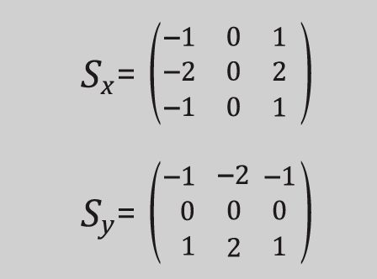
kernel_size=3是最小的内核大小，实际上可以是任何奇数；
较大的内核，采取更平滑的梯度；
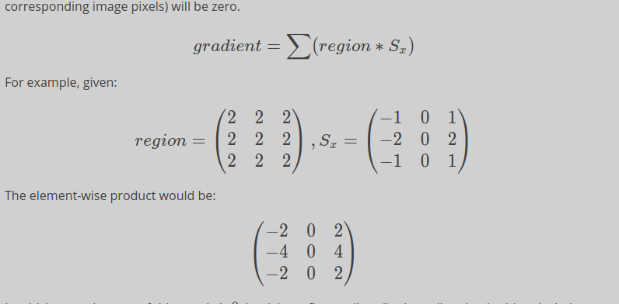
如果图像水平方向是平滑的，积分和就是０
Examples of Useful Code
You need to pass a single color channel to the cv2.Sobel() function, so first convert it to grayscale:
gray = cv2.cvtColor(im, cv2.COLOR_RGB2GRAY)
Note: Make sure you use the correct grayscale conversion depending on how you've read in your images. Use cv2.COLOR_RGB2GRAY if you've read in an image using mpimg.imread(). Use cv2.COLOR_BGR2GRAY if you've read in an image using cv2.imread().
Calculate the derivative in the x direction (the 1, 0 at the end denotes x direction):
sobelx = cv2.Sobel(gray, cv2.CV_64F, 1, 0)
Calculate the derivative in the y direction (the 0, 1 at the end denotes y direction):
sobely = cv2.Sobel(gray, cv2.CV_64F, 0, 1)
Calculate the absolute value of the x derivative:
abs_sobelx = np.absolute(sobelx)
Convert the absolute value image to 8-bit:
scaled_sobel = np.uint8(255*abs_sobelx/np.max(abs_sobelx))
2.magnitude梯度的度量
magnitude实际上是x,y方向的梯度平方和的平方跟；
可以修改sobel核的大小，以改变应用渐变的区域大小；

step1:camera calibration 校准镜头
计算校准矩阵
step2:distortion correction 去除图像畸变
求畸变参数
step3:color & gradient threshold颜色和梯度阈值
创建一副二进制图像，用阈值参数过滤
step4:perspective transform透视变换
应用透视变换

经过以上４步，得到如下图像
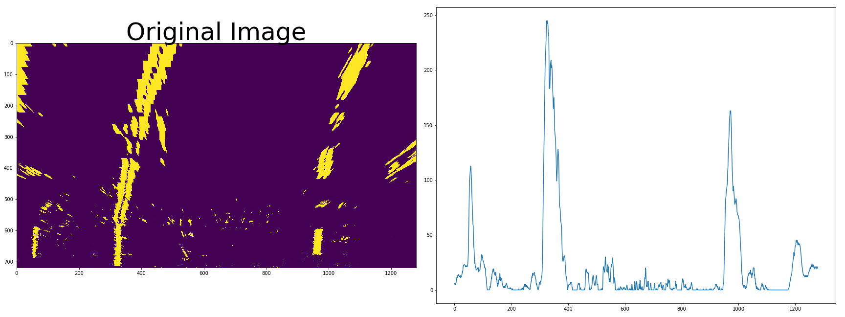
step5:通过滑窗来拟合四边形
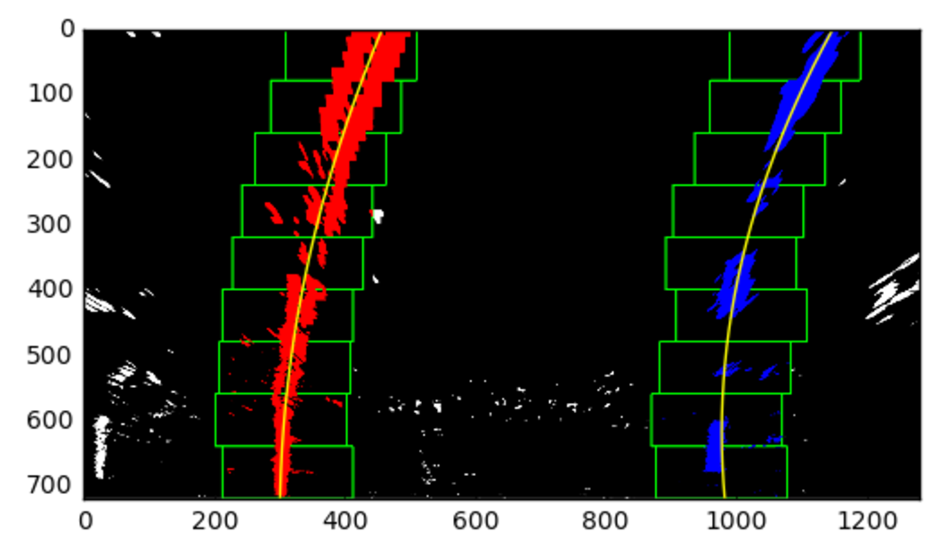

使用梯度下降法：
代价函数必须符合，连续函数，可微；

从离散到连续的方法：
将激活函数从阶跃函数，变成sigmoid函数；
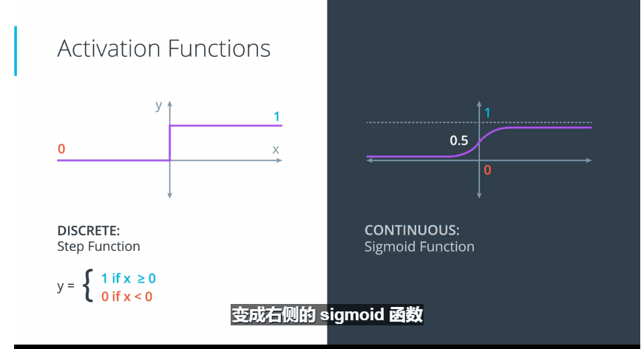

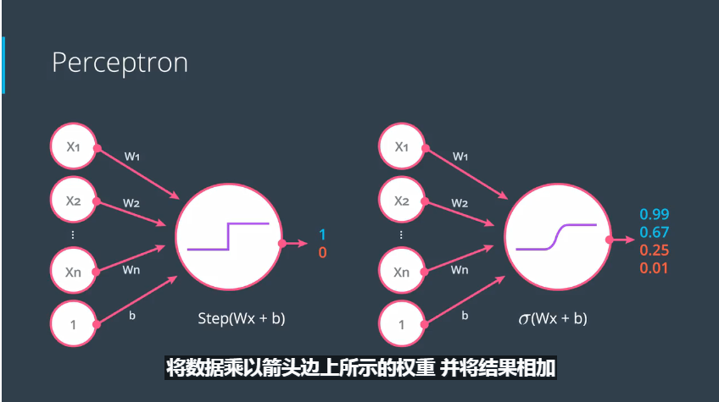

对于多分类问题，激活函数用softmax函数
def softmax(L):
expL = np.exp(L)
sumExpL = sum(expL)
result = []
for i in expL:
result.append(i*1.0/sumExpL)
return result

当二分类时，sigmoid函数是softmax函数的特例；

利用极大似然估计，求概率对数相反数，得到交叉熵；
模型越好，概率越大，交叉熵越小；

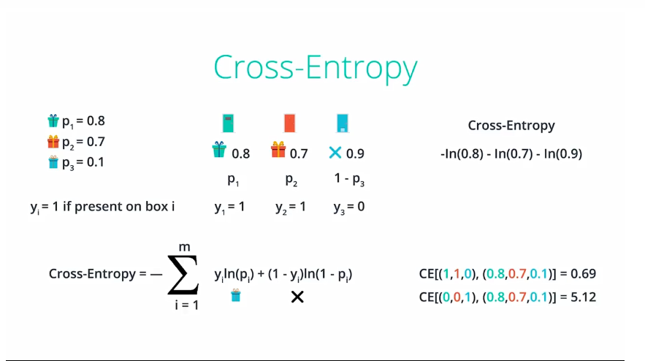
交叉熵计算公式：
import numpy as np

def cross_entropy(Y, P):
Y = np.float_(Y)
P = np.float_(P)
return -np.sum(Y * np.log(P) + (1 - Y) * np.log(1 - P))

